Software

Project Plan

for

Online bookstore

Distribution:

<RPI., Name>

Appendices:

Table of Content

1. Overview 3

2. Goals and Scope 3

2.1 Project Goals 3

2.2 Project Scope 5

2.2.1 Included 5

2.2.2 Excluded 5

3. The shareholders 5

4. Organization 6

5. Project management 7

5.1 Software development method 7

5.2 Software Management Tools 7

6. The project deliverables 8

6.1 The snapshot of software product 8

6.2 The artifacts of the each phase of the project 9

6.3 The project schedule for each deliverable 10

7. Quality assurance 10

8. Software change management 11

|  |  |
| --- | --- |
| Version | Description |
| 1.0 | The basic |
| 1.5 | Add the content and chart |
| 2.0 | The final version of software project plan |

# Overview

The project is to create an online bookstore which include the basic function of an online store including showing products, adding to the cart, buying the product online. Its target customers are buyers who hope to get books, especially well-chosen relaxing book online with ideal price. In fact, the project is based on the incomplete clothes store whose online address is <https://github.com/lawiet019/FinalProjectForDB/invitations>.

And it takes around two months to finish the whole project.

The language used in this project is Python and the main framework is Django which is Python-based free and open-source web framework and follows the model-template-view architectural pattern.

The production environment is Win10. To run the project, a new user should pip install requirements.txt. And run the server by command python manage.py runserver.

The database used in this project is sqlite3 which is embedded in the Django project.

# Goals and Scope

## Project Goals

| **Project Goal** | **Priority** | **Comment/Description/Reference** |
| --- | --- | --- |
| **Functional Goals:** | 2 | For details see the Project Requirements Specification [2] |
| <functional goal #1> | Display the product | It is better to display all the products by category. This feature is not realized by original project; Change the default setting |
| <functional goal #2> | Show the detail of product | We can realize the function based on the original function by adjusting our database and front-end part to change it from a clothes store to a book store;  Fix some bugs like the path of image |
| <functional goal #3> | Add the cart | Adjust the database part during the process |
| <functional goal #4> | Login | All those parts including the signing in , signing up and forget password is based on the plugin in the Django named django-allauth |
| <functional goal #5> | Payment | Define the process and all the fields need in the process of payment. |
| **Business Goals:** | 4 |  |
| <Time-to-market> | Time | The product should deliver in two months |
| <efficiency, cost, quality> | Quality | The function on the project should work |
| **Technological Goals:** | 1 |  |
| <technical goal #1> | Understand original project | We should understand the workflow and the mechanism of Django |
| <technical goal #2> | Fix problems existing on original project | Find the existing problems and the difference between the expected bookstore and the original clothes store.  And change the code from different perspectives from the front-end, back-end to database. |
| **Quality Goals:** | 3 |  |
| <quality goal #1> | Front-end | All the elements display normally;  Use the template to reduce redundancy |
| <quality goal #2> | Back-end | Return the needed data from the template; |
| <quality goal #3> | Database | All the field defined in the proper way and insert reasonable data |
| **Constraints:** | 5 |  |
| <environmental> | Product environment | Win 10 |
| <version of language > | Language | Use the python3.7 and Django 2.2 |

## Project Scope

Help: Clarify what the project will (and will not) deliver, in order to avoid future shifts in the level of ambition.

### Included

The project will include:

Stage 1: Project analysis documents and project design documents( Focus on the specific function and whole workflow of project.

Stage 2: Since our project is based on an existing project, so the project should include the parts of understanding all the codes. And finding the bugs existing in the original project and the difference between existing project and our expectation.

Stage 3: The implementation of the bookstore including displaying the books by categories, showing the details of books, add books into shopping cart, buying the book.

Stage 4: Test the code from different perspectives including the realization of function, test the bugs in the code.

### Excluded

The exclude part is mainly about the functionality of payment. Since it is just demo of the bookstore, we did not provide the mechanism to test whether their secure code match their card. In that case, they cannot finally realize make a order.

# The shareholders

|  |  |
| --- | --- |
| **Roles** | **Descriptions** |
| Funders/customers | The potential funders will be the traditional book seller who has the intention to transfer their business mode |
| Users | Buyers who hope to get books, especially well-chosen relaxing book online with ideal price |

# Organization

To clarify the whole division of labour, I drawn an Organizational chart (Fig1) by process on. 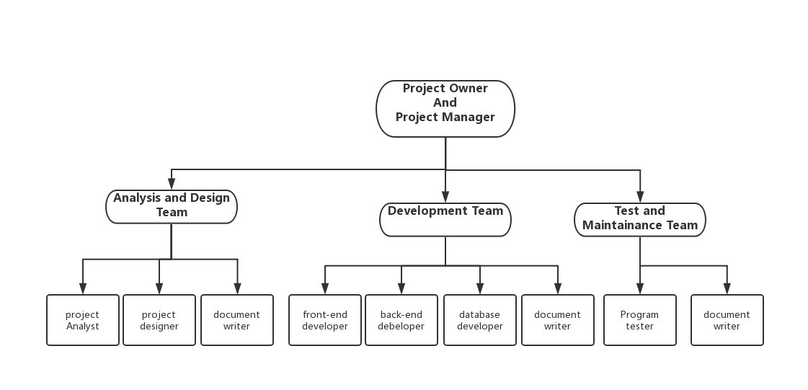

**Fig1**

Since our team only has two people, I will use the task table to show our division of work

|  |  |  |  |  |
| --- | --- | --- | --- | --- |
| Role | Sub-role | Mosley Arthur | Yufei Wu | Description |
| Project Owner  And  Project Manager | | √ | √ | The management of whole project |
| Analysis and design team | Project  Analyst | √ | √ | The plan and detailed design of whole project |
| project designer | √ | √ |
| Document writer | √ | √ |
| Development Team | front-end developer |  | √ | The implementation of bookstore |
| back-end  developer | √ | √ |
| Database developer | √ |  |
| Document writer |  | √ |
| Test and Maintenance Team | Program tester |  | √ | The test of work of program |
| Document  writer | √ | √ |
| Other( PPT) | | √ |  |  |

# Project management

## Software development method

We used the Agile as the software development methodology. To be more specific, We used the Dynamic systems development method. In other words, we focus our attention mainly on the quality, time and cost while not guaranteed all the features to be realized. And realize the functions iterative and increment.

The MoSCoW Prioritization chart is the Fig2 which shows the tasks that must do, should do, could do and won’t do.

**Fig2**

## 5.2 Software Management Tools

* Use git and github to do the version control tasks

We choose Taiga and Gantt Project as management tool to control the whole project.

* Use Taiga to create a project name final project
* Track the bugs and problem in this project and set their attributes and assign those tasks to different people as Fig3

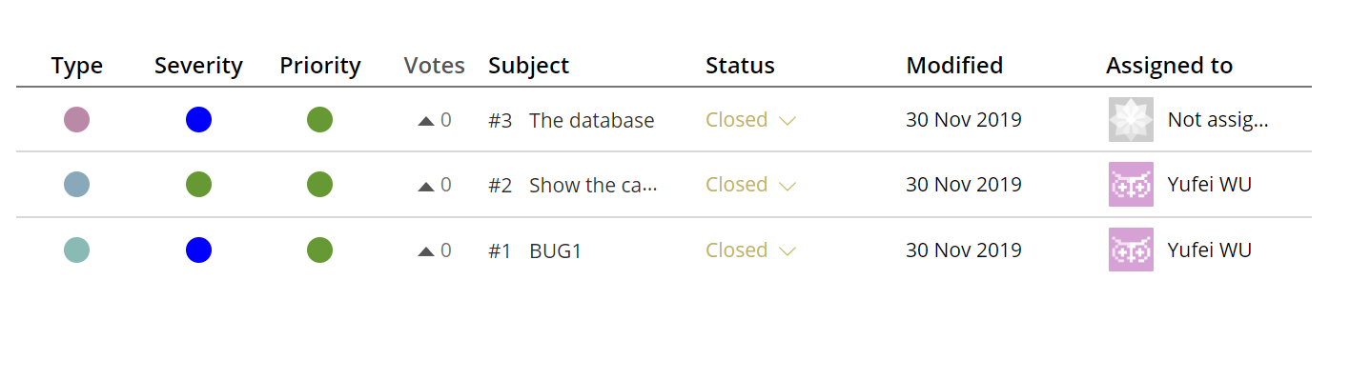

Fig3

* Create the burn down image as Fig4. In an ideal situation, we are supposed to do all the work evenly. But this one mainly record the process of documents and code rather than design in sketch and communications. So, it starts from November.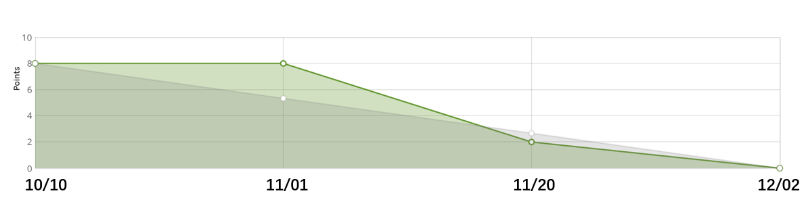
* Use the Gantt Project Create the milestones and schedule and dependency as Fig5

There are four main tasks in the chart including the document writing, front-end part, back-end part, database part and set two milestones including finish the design and analysis and finish the project.

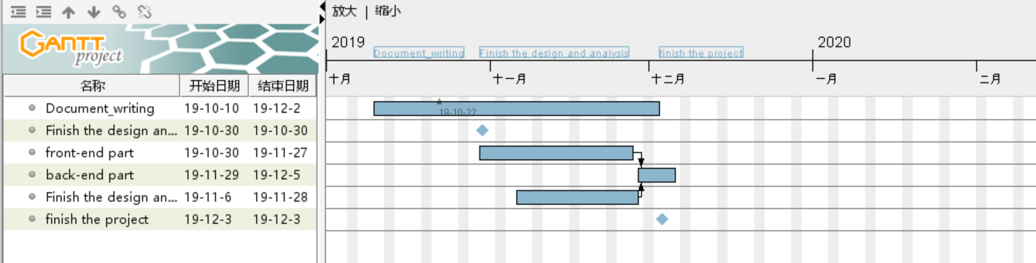

# The project deliverables

## The snapshot of software product

**Sign in:**

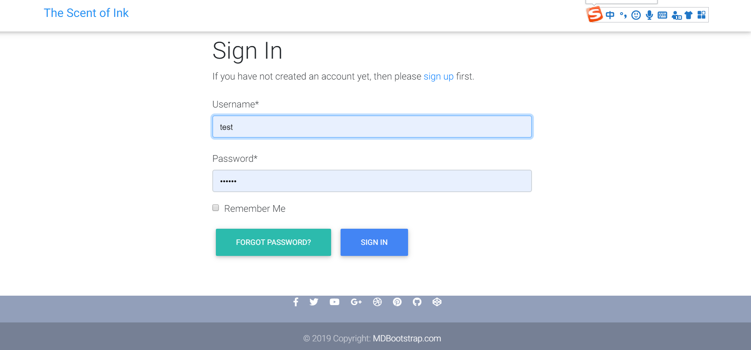

**Reset password:**

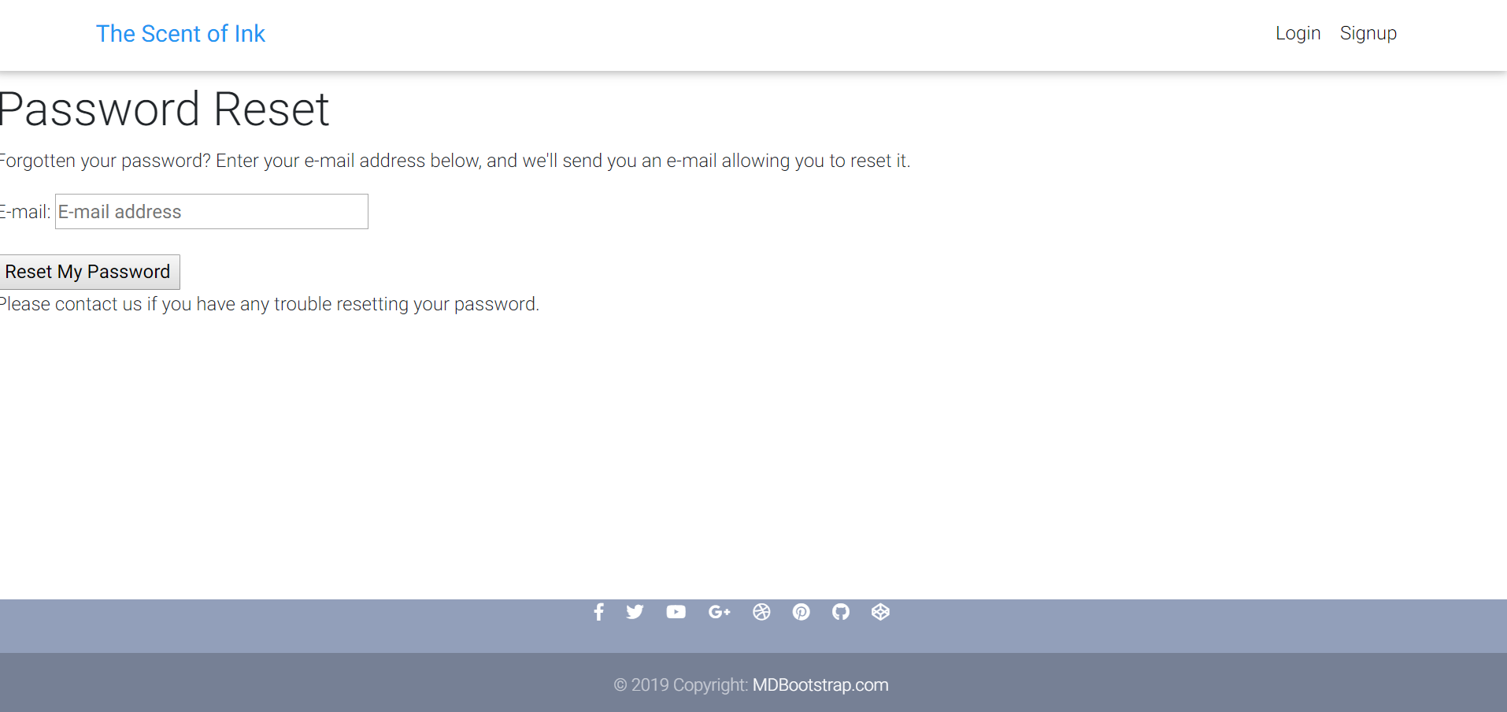

**Sign up :**

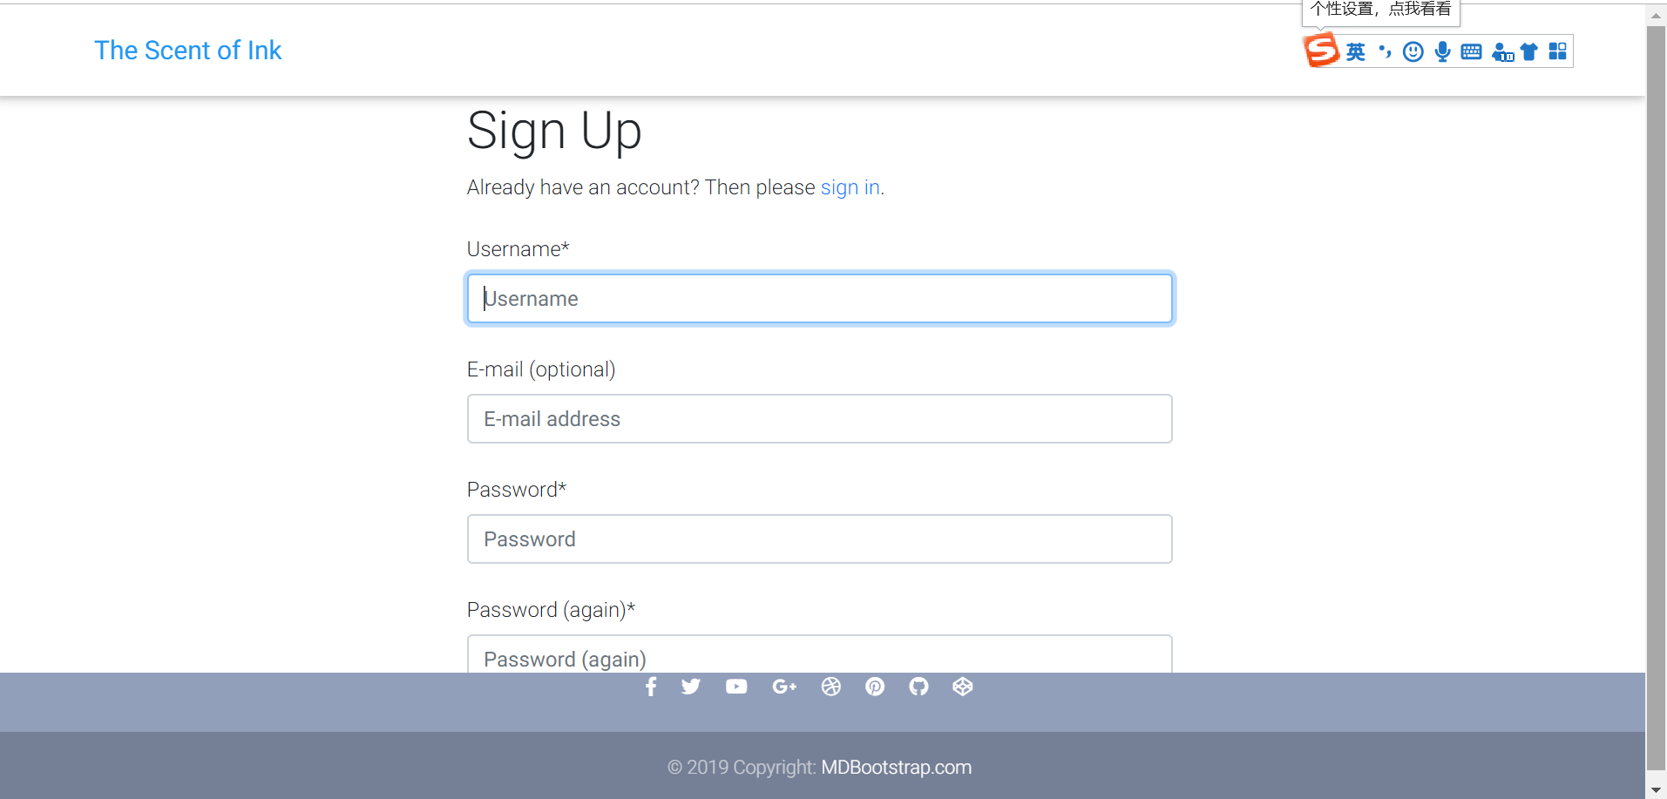

## The artifacts of the each phase of the project

* The design and analysis phase:
  + Most part of Software Project Plan; The Software Functional Specification Document;
  + In that phase, we should have a overall view of our plan and a specific understanding of our project; most of the System Configuration

Documentation

* The implementation phase:
  + Software product; most part of The Software Design Documentation; most of the System Configuration Documentation
  + The that part, it mainly focus on how to develop the project
* The test and deployment phase:
  + Part of The System Configuration,;part of The Quality Assurance Plan
  + This part is mainly about the code and document of unit test, integrated test and deployment.

## The project schedule for each deliverable

|  |  |  |
| --- | --- | --- |
| Deliverable | DDL | Responsible person |
| Software Product | 2019.11.28 | Mosley Arthur; Yufei Wu |
| Software Project Plan | For overview:  For deliverable:2019.12.1 | Yufei Wu |
| The Software Functional Specification Document | 2019.11.1 | Mosley Arthur |
| The Software Design Documentation | 2019.11.25 | Yufei Wu |
| The System Configuration  Documentation | 2019.12.2 | Yufei Wu |
| The Quality Assurance Plan | 2019.12.2 | Mosley Arthur |
| PPT | 2019.12.2 | Mosley Arthur |

# Quality assurance

The part is composed by those question and answers

* What are the applicable quality standards?

ISO 9000: This standard is based on seven quality management principles which help the organizations to ensure that their products or services are aligned with the customer needs’. Seven quality management principles can

be seen as follows:

* + Customer focus
  + Leadership
  + Engagement of people
  + Process approach
  + Improvement
  + Evidence-based decision making
  + Relationship management

To be more specific, the quality control mainly focus on the management of whole project and the product of project including the document and the software.

* How will quality be measured?
  + The documents in every phase and the unit test for the code
* Who will measure it?
  + The project owner
* What will be measured?
  + To be more specific, the code should test the query of database
  + And we can test the front-end part with different browsers and different computers.
  + We should check whether every function in the design phase has been realized
* When will it be measured?
  + The end of every phase
* What is the criteria for rejection?
  + Did not realize the function that must be realized.
  + The code cannot run

# Software change management

The Change Management Plan documents and tacks the necessary information required to effectively manage project change from project inception to delivery.

The workflow of software change will be like the image below

We will try to use the project management tool to track the whole project. Firstly, we will use the Taiga to request an improvement like Image below

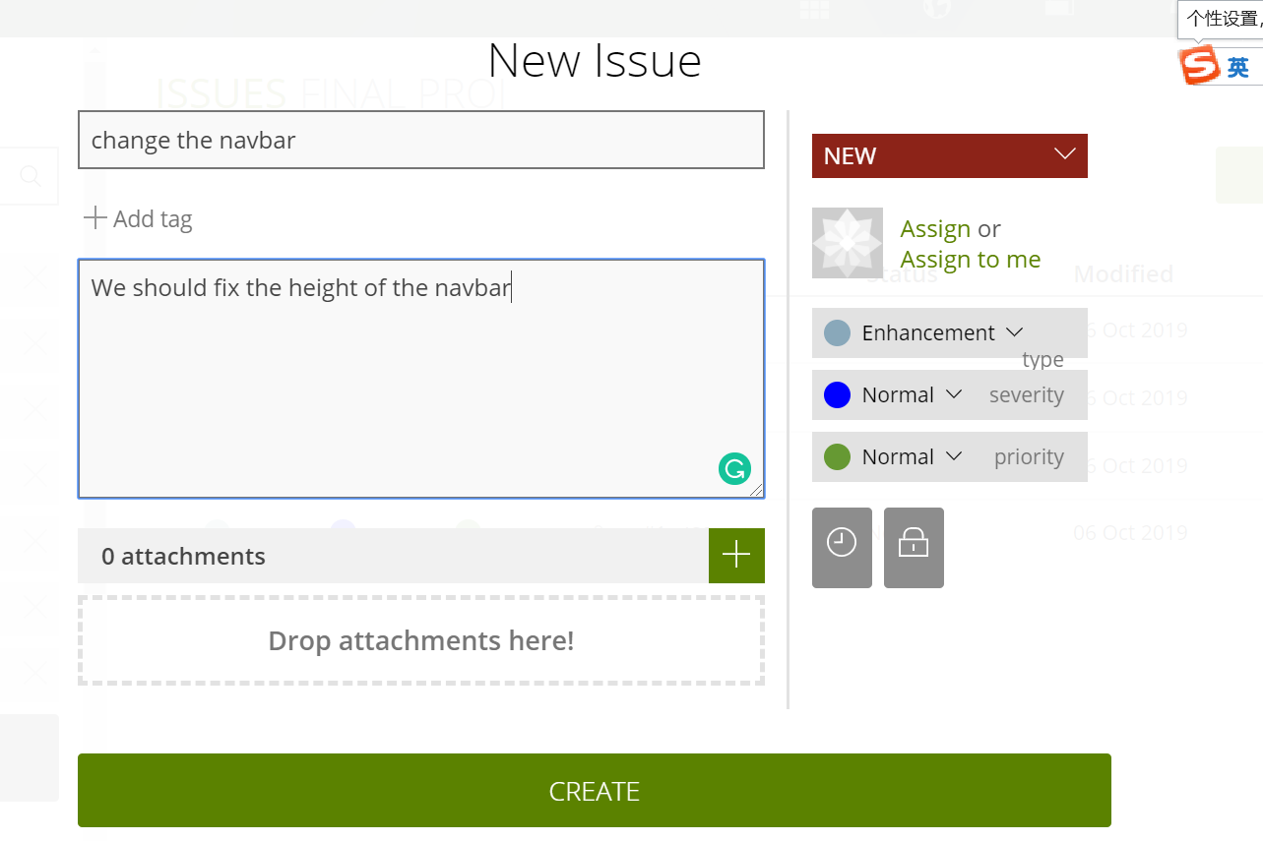

For every issue, there will be a vote as the image below . For our project, we have two project owners, so if every enhancement gets two votes, it can be applied.



Then the one who are assigned to change the part should work on his or her own computer. And do test on the changed code the whole code If the change part really works, people could just push it to the GitHub.